Title (Style 01 – Font size: 20; Alignment: centered)

Author’s name (Style 02 – Font size: 16; Alignment: centered)
Author’s affiliation (Style 02)
First headline (Style 03 – Font size: 16, Format: underline; Paragraph spacing (before): 30, not allow hanging punctuation)
First paragraph under the headline. (Style 04 – Latin text font: Times New Roman, size: 14, Character spacing: normal; Alignment: justified, Indentation: 28 (first line), Paragraph spacing (before): 0, Line spacing: at least 21, not allow hanging punctuation). However, if the first paragraph is not preceded by a headline, then (Style 12 – Paragraph spacing (before): 30, other Format same as Style 04).
Second and the following paragraphs under the headline (Style 05 – Paragraph spacing (before): 12, other Format same as Style 04).
Second and the following headlines (Style 06 – Font size: 16, underline; Paragraph spacing (before): 18, not allow hanging punctuation)
First paragraph under the headline (Style 04).
Second and the following paragraphs under the headline (Style 05).
Other requirements
Page setup. Margins: top, bottom, left, right: 72, Portrait A4, No grid.
Mathematical symbols. Numerals: regular font style, e.g. 12 cm. Variables: Italic, e.g. f (x) = x² . Standard functions: regular font style, for example e^{ix} = cos x + i sin x . For other mathematical symbols: insert from Symbol where possible, e.g. ADE ≅ CFE , ∠ABC = 30°. Greek alphabet: Symbol (regular font style), e.g. α + β = π . Word 2010 built-in equations editor: e.g. $\sqrt{2}$ , $\frac{1}{2x+1}$ . Equation editor 3.0: Scale: 116% , e.g. , .
Footnote. Bottom of page, number font. Please refer to the footnote .
Figures. (Style 08 – Alignment: centered, Indentation: 0, Paragraph spacing (before): 12; Picture wrap text: in line with text, Picture color: 0% saturation (i.e. grayscale) as shown below.
Figure number under the figure (Style 09 – Latin text font: Times New Roman, size: 14; Alignment: centered, Paragraph spacing (before): 6) as shown below.
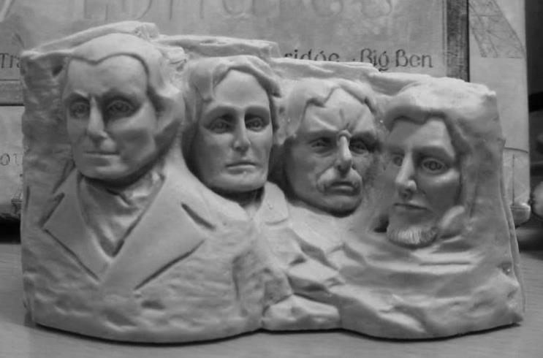
Figure 1
When citing an article, the number of year should be stated, e.g. Chow (1997) suggested that … .
References
(Style 10 – Latin text font: Times New Roman, size: 12, Character spacing: normal; Alignment: justified, Indentation: hanging (24), Paragraph spacing (before): 6, Line spacing: at least 18, not allow hanging punctuation)
Author of book (year of publication). Name of book. Place of publication: Publication company. Example below.
Morris, P. (1996). The Hong Kong school curriculum: Development, issues and policies (2nd edn.). Hong Kong: Hong Kong University Press.
Author of article (year of publication). Title of article. In Editors. Name of the book, xxx– xxx. Place of publication: Publication company. Example below.
Siu, F. K., Siu, M. K., & Wong, N. Y. (1993). Changing times in mathematics education: The need of a scholar-teacher. In C. C. Lam, H.W. Wong, & Y. W. Fung (Eds.), Proceedings of the International Symposium on Curriculum Changes for Chinese Communities in Southeast Asia: Challenges of the 21st Century, 223–226. Hong Kong: Department of Curriculum and Instruction, the Chinese University of Hong Kong.
Author of article (year of publication). Title of article. Name of the journal, volume, xxx– xxx. Example below.
Capraro, M. M. (2005). A more parsimonious mathematics beliefs scales. Academic Exchange Quarterly, 9, 83–89.
Author’s e-mail: edumath@hkame.org.hk (Style 11 – Latin text font: Times New Roman, size: 12; Paragraph spacing (before): 30, Line spacing: at least 18)

All measuring units in this template are in Points (1 inch = 72 points).
Footnote (Style 07 – Latin text font: Times New Roman, size: 12; Alignment: justified, Indentation: 15 (hanging), Paragraph spacing (before): 6, Line spacing: at least 18, not allow hanging punctuation)

